UniBoard: generic hardware for radio astronomy signal processing

J. E. Hargreaves*ª
ªJoint Institute for VLBI in Europe (JIVE), Oude Hoogeveensedijk 4, 7991 PD Dwingeloo
The Netherlands

Abstract
UniBoard is a generic high-performance computing platform for radio astronomy, developed as a Joint Research Activity in the RadioNet FP7 Programme. The hardware comprises eight Altera Stratix IV Field Programmable Gate Arrays (FPGAs) interconnected by a high speed transceiver mesh. Each FPGA is connected to two DDR3 memory modules and three external 10Gbps ports. In addition, a total of 128 low voltage differential input lines permit connection to external ADC cards. The DSP capability of the board exceeds 644E9 complex multiply-accumulate operations per second.
The first production run of eight boards was distributed to partners in The Netherlands, France, Italy, UK, China and Korea in May 2011, with a further production runs completed in December 2011 and early 2012.
The function of the board is determined by the firmware loaded into its FPGAs. Current applications include beamformers, correlators, digital receivers, RFI mitigation for pulsar astronomy, and pulsar gating and search machines
The new UniBoard based correlator for the European VLBI network (EVN) uses an FX architecture with half the resources of the board devoted to station based processing: delay and phase correction and channelization, and half to the correlation function. A single UniBoard can process a 64MHz band from 32 stations, 2 polarizations, sampled at 8 bit. Adding more UniBoards can expand the total bandwidth of the correlator. The design is able to process both pre-recorded and real time (eVLBI) data.

Keywords: FPGA, DSP, Correlator, VLBI

INTRODUCTION
The aim was to create a generic platform for radio astronomy signal processing with as much processing power and IO as could reasonably fit on one board. Standard 10 gigabit Ethernet interfaces would be used for IO and front-to-back symmetry would allow data flow in both directions. All processing nodes would be identical and as generic as possible so that the same hardware could be used for many applications.
This paper gives an overview of the UniBoard hardware and the control system developed for it in sections 2 and 3 respectively. In section 4 the tools used for application development are described and examples of current applications given. A more detailed description of one application, the new EVN correlator under development at JIVE, is given in section 5.

* hargreaves@jive.nl; phone +31 521 596517

THE UNIBOARD HARDWARE
A block diagram of the UniBoard hardware is shown in Figure 1. The large squares denoted FN (front node) 0-3 and BN (back node) 0-3, represent the eight Altera EP4SGX230 FPGAs. Each FPGA contains 1288 eighteen bit multipliers, 182400 registers and 14.6Mbits internal static RAM. Four multipliers can be configured as a nine bit complex multiplier. Given a realistic system clock rate of 250MHz the whole board could perform 644E9 complex multiply-accumulate operations per second. Two 64bit, 1066MT/s SODIMM slots allow up to 8GB DDR3 storage per FPGA. Each FN is connected to each BN by a 24Gbps fully duplex transceiver mesh. Only the connections to FN0 and BN0 are shown in Figure 1 for clarity.
External connections differ slightly between the front and back nodes. All nodes have four external ten-gigabit Ethernet ports, although currently only three can be used simultaneously due to internal routing restrictions in the FPGAs. The FNs are provided with SFP+ cages, whilst the BNs use CX4 copper connectors. Additionally each BN has 32 LVDS input pairs. Two differential pair inputs are distributed to all eight FPGAs: one for use as an external system clock and the other as a global sync pulse such as a PPS.
The power requirements are a -48V supply at 10A, with typical consumption of 2.5 to 7A depending on the application.

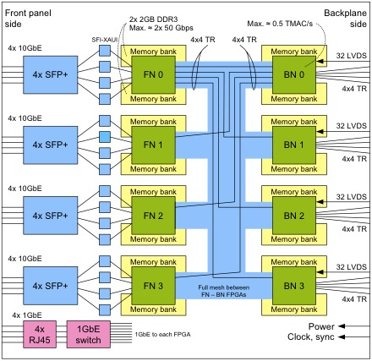
Figure 1. Block diagram of the UniBoard hardware

A single chip gigabit Ethernet switch, shown at the bottom left of Figure 1, provides a 1Gbps control connection to each FPGA. A JTAG boundary scan bus permits continuity testing between major components and downloading the FPGA firmware, either directly to the FPGA or to a non-volatile EEPROM placed beside each FPGA. The EEPROMs can hold up to three compressed images: typically a safe power-up configuration and one or two application configurations. It is possible to reprogram the EEPROM via the Ethernet control port, so that the JTAG cable can be removed in production installations.

CONTROL SYSTEM
There is no dedicated control hardware on the UniBoard. Instead control functions are implemented as part of the firmware for each FPGA using, for example, a soft processor or state machine. Applications developed to date use the Nios2 soft processor provided by Altera. Control/status registers are created as needed within the application specific design modules and connected into the Nios2 memory map. Figure 2 shows two alternative control paths between an external control computer and Nios2 processors embedded in the FPGAs.

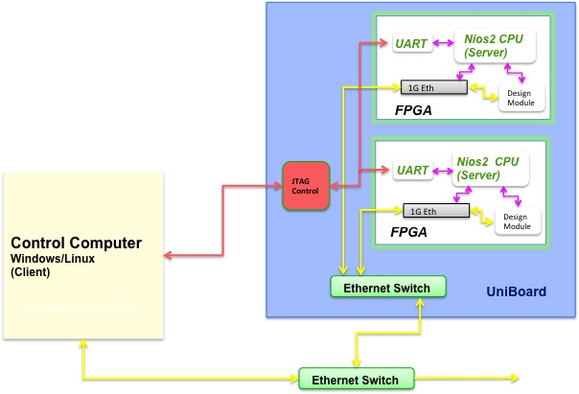
Figure 2. UniBoard control system

JTAG control
It is feasible to control simple, single UniBoard, systems over the JTAG interface. Software provided by Altera allows communication between a terminal window on a PC and a Nios2 processor via a serial port (the UART in Figure 2). The designer must write a C program to transfer data between the serial port and the control registers in the design.

Ethernet control
For controlling multiple UniBoards it is more effective to communicate over the Gigabit Ethernet port. A simple control packet format has been developed to transmit instructions to read, write, or modify registers. The UDP protocol is used to avoid the overhead associated with TCP. The Nios2 returns an acknowledgment for every command issued by the control system so that lost packets are detected and re-sent. The server side is a compact (15kB) embedded ‘operating system’ dubbed UNB_OS, which was developed at JIVE. The client side was written in Erlang, though languages such as Python and TCL can also be used.

Erlang
Erlang is a high level functional programming language developed in the telecommunications industry specifically for controlling hardware at the register bit level. Several features: single assignment variables, no global variables and, as processing is list based, no looping constructs, reduce side effects and increase robustness¹. A key advantage for the UniBoard project is that an operation can be performed on multiple FPGAs on many UniBoards as easily as on one. A library of Erlang functions developed at JIVE allows read, write and modify access to registers in any UniBoard application.

APPLICATIONS

Firmware development
Firmware is usually written in VHDL or Verilog with synthesis and fitting using the Quartus software from Altera. Extensive use is made of Altera MegaWizard IP blocks for infrastructure functions such as the 10 Gigabit Ethernet ports, DDR3 controllers, DSP functions and FIFOs. Finished designs and modules are shared between the project partners using an SVN repository. ModelSim is used for functional simulation and the timing analysis tools within Quartus to verify timing closure.

Current applications
A number of applications are currently under development. In the Netherlands, ASTRON will fit focal plane array feeds to antennas in the Westerbork array as part of the APERTIF project². A total of 128 UniBoards will be used to first beamform and then correlate the data from the feeds. Comoretto et al³ of INAF have developed a digital receiver capable of converting an 8GSps ADC output to standard VLBI Data Interchange Format (VDIF⁴) formatted sub-bands of up to 64MHz per channel. The design will be used by telescopes in the European VLBI Network (EVN) to transmit data in real time to the new UniBoard based correlator at JIVE. More details of the EVN correlator design are given in the next section.
Shanghai Observatory are developing a UniBoard based correlator for the Chinese VLBI network and a digital backend for the new Shanghai 65m antenna⁵. At the University of Manchester AhmedSaid et al⁶ are developing two pulsar applications: coherent de-dispersion of a 1GHz beam, and an 8192 channel, >1000 dispersion measure pulsar search machine.

THE EVN CORRELATOR APPLICATION

Introduction
Table 1 lists the main performance specifications of the EVN correlator. The data source can be either pre-recorded or streamed over a network directly from the antennas (eVLBI). In either case data arrive at the UniBoard 10 Gigabit Ethernet ports in UDP encapsulated VDIF frames. A single VDIF frame contains data from one sub-band from one source. For dual polarization data, both polarizations may be placed together in a VDIF frame. Single and dual polarization data can be mixed between different sources, as can the sampling resolution. Similarly, the correlator is always set up to receive data from 32 stations. Any correlation products resulting from unused polarizations and stations are disabled at the output.
Table 1. EVN correlator specifications.
SPECIFICATIONS

Input Processing
Stations 32 Integration time 22ms – 1s
Polarizations 2 Correlation products 2112 full stokes
Resolution 1-8bits Spectral resolution 15kHz
Format VDIF
Sub-banding 1,2,4,8,16,32,64MHz
Total Bandwidth 4096MHz

A single UniBoard can correlate 64MHz of input bandwidth. Adding UniBoards expands the total bandwidth of the correlator: 64 boards would achieve the required total of 4096MHz. The correlator employs an FX architecture, with the station based processing and channelization done in the FNs and the correlation operation in the BNs.

FN signal flow
Before correlating VLBI data, it is necessary to align signals from widely separated stations. Arriving data are written into a slot within a 2 second long circular buffer. The write address is calculated from the timestamp in the VDIF header, automatically compensating for variable network delays and out-of-order packets. The read address is calculated using a geometrical delay model to adjust for the location each station. This calculation is done in the box marked ‘delay model’ in Figure 3 using coefficients pre-loaded by the control system. Adjusting the read address allows the delay to be compensated to a resolution of one sample, and is represented by the arrow from ‘delay model’ to ‘packet receiver’ in Figure 3.
A phase adjustment must be applied per sub-band because of the difference between the sky frequency and baseband. This ‘fringe-stopping’ correction is also calculated in the delay model module and applied at a mixer at the input to the filter bank. The data are then channelized in a polyphase filter bank denoted by the boxes ‘pre-filter structure’ and ‘FFT’ in Figure 3. At the output of the FFT a fraction delay correction, to a resolution of 1/16th of a sample, is applied before the data are normalized, truncated to 9 bits, and streamed across to the the back nodes.
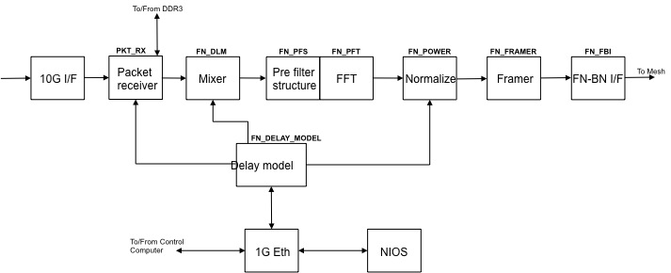
Figure 3. EVN Correlator signal flow: front node

The box labeled ‘Framer’ divides the channelized data between the BNs so that like parts of the spectrum arrive for correlation at the same FPGA.

BN signal flow
Before correlation a corner turning operation is performed. Data arrive from the FNs in time order, one FFT period at a time, and are stored in one of the DDR3 modules. When a whole integration period of data has been stored, the data are read out, and correlated in frequency bin order. The correlated products are not stored in the FPGA but must be exported through the 10 Gigabit port to make way for the next frequency bin. The read and write DDR3 modules swap every integration period so that data can be processed continuously.
It was necessary to use the corner turning architecture because there is not enough storage inside the FPGA to accumulate 2112 products x 1024 frequency bins. Neither is the DDR3 interface fast enough to store the intermediate accumulated products in the DDR3 modules.

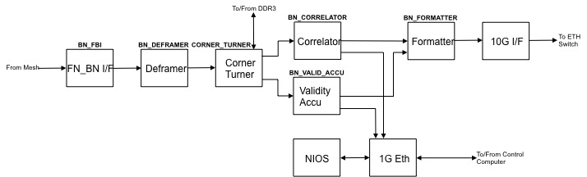
Figure 4. EVN Correlator signal flow: back node

Figure 4 shows the signal flow through the corner turner and correlator modules. The correlator consists of 132 cells each comprising a 9x9 bit complex multiplier and 36 bit complex accumulator. The MAC cells are clocked at 266MHz and each calculates 16 products.

Validity bits
Validity bits flow through the system in parallel with the data. In the FN packet receiver a single bit indicates whether data have arrived for a given time slot. These validity bits are monitored when the data are read out and sent to the filter bank. If any of the data contributing to a given FFT period are not valid, all the frequency bin outputs for that FFT period are marked not valid. The FN framer module sets any invalid FFT outputs to zero so that they will not contribute to the correlation products. The FFT validity bits are transmitted to the BNs along with the data and stored in parallel with the corner turner data. When the data is processed in the correlator engine, the relevant validity bits are accumulated in the module labeled ‘validity accu’ in Figure 4. The result is the total number of valid frequency bin samples used to calculate that product and is used to normalize the product.

Acknowledgements
Poster presented on behalf of the UniBoard collaboration. UniBoard is a research activity of Radionet FP7. This activity is supported by the European Community Framework Programme 7, Advanced Radio Astronomy in Europe, grant agreement no.: 227290.

References
- Verkouter, H., “Erlang: Functional programming for real-world applications”, JIVE internal presentation, 14 April 2009
- Gunst, A., "The UniBoard: a multi purpose FPGA rich board”, ASTRON internal presentation, June 2010.
- Comoretto, G., Russo, A., Baudry, A., Cais, P., Camino, P., Quertier, B., “Digital Receiver”, UniBoard face to face meeting, Bordeaux, 12-13 October 2010.
- VLBI Data Interchange Format (VDIF) Specification, Release 1.0, Ratified 26 June 2009, Madrid, Spain, http://www.vlbi.org/vdif
- Zhang, X. Z., Xiang, Y., Zhu, R. J., Xu, Z. J., Wu, Y. J., Luo, J. T., Yu, W., Guo, S. G., Zhang, B. J., “The UniBoard Requirement in Shanghai Astronomical Observatory”, UniBoard face to face meeting, Bordeaux, 12-13 October 2010.
- AhmedSaid, A, Shenton, C., Ferdman, R., Stappers, B., “UniBoard Pulsar Project Definition”, project internal document, 11 November 2011

